BUILD MOBILE APP

CONFIGURE THE APPLICATION TO RECEIVE THE DATA FROM
CLOUD

Date | 09 November 2022
Team ID | PNT2022TMID00966
Project Name | Project – Real Time River  Water Quality Monitoring and Control System
Maximum Marks | 4 Marks

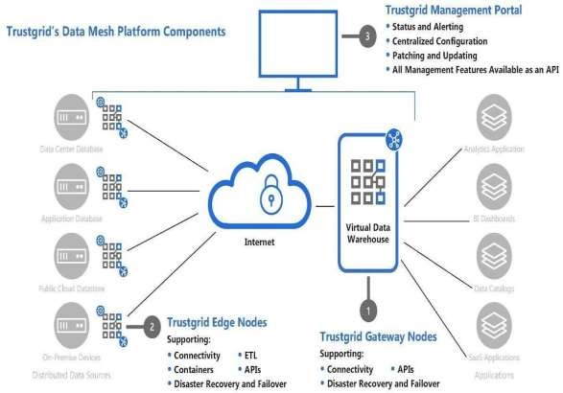


This Virtual Data Warehouse allows for the virtual aggregation of data so that an application (or many applications) can easily consume it. Once a data source is added to the Virtual Data Warehouse an application has secure, real-time, persistent access to that data set.

